

|  |  |
| --- | --- |
| **Project Title** | REsearch INfrastructures FOR Citizens in Europe |
| **Project Acronym** | REINFORCE |
| **Grant Agreement No.** | 872859 |
| **Start Date of Project** | 01.12.2019 |
| **Duration of Project** | 36 months |
| **Project Website** | [www.reinforceeu.eu](http://www.reinforceeu.eu) |
| Sonification Scripts Manual | |
| **Work Package** | WP7 - Increasing the senses, increasing inclusion |
| **Lead Author (Org)** | B. Garcia (CONICET) |
| **Contributing Author(s) (Org)** | N. Bertaina (IBFI), J. Casado (ITDA, IBFI), P. Chanial (EGO), G. de la Vega (ITDA), W. Diaz-Merced (EGO),  G. Hemming (EGO), C. Hettlage (SAAO),  S. Katsanevas (EGO), F. Spagnuolo (EGO) |
| **Due Date** | 31.05.2022 |
| **Date** | 31.05.2022 |
| **Version** | 1.0 |

|  |  |
| --- | --- |
| **Dissemination level** | |
| X | PU: Public |
|  | PP: Restricted to other programme participants (including the Commission) |
|  | RE: Restricted to a group specified by the consortium (including the Commission) |
|  | CO: Confidential, only for members of the consortium (including the Commission) |

|  |
| --- |
| **Disclaimer**  This document contains information which is proprietary to the REINFORCE Consortium. Neither this document nor the information contained herein shall be used, duplicated or communicated by any means to a third party, in whole or parts, except with the prior consent of the REINFORCE Consortium. |

**Document Control**

|  |  |  |  |
| --- | --- | --- | --- |
| **Version** | **Author/**  **Reviewer** | **Status** | **Date** |
| 0.1 | B. Garcia (CONICET, WP7 Leader), J. Casado (CONICET, WP7 member) | First version. | 19 Jun, 2022 |

**Table of contents**

​1​ Introduction **8**

​2​ The sonoUno sonification platform **8**

​2.1​ The web-based version of sonoUno 9

​2.1.1​ The development framework 9

​2.2​ The code base 9

​2.2.1​ Developments to the web interface 9

​2.2.1.1​ Improved responsiveness 10

​2.2.1.2​ Improved custom-data usage 13

​2.2.1.3​ Improved accessibility 14

​2.2.1.3.1​ Text-input of values alongside sliders 14

​2.2.1.3.2​ Command-line function-access 15

​2.2.1.3.3​ Plot-grayscale option 15

​2.2.1.3.4​ Frequency inversion 15

​2.2.1.5​ The peak-finder functionality 15

​2.3​ The desktop-based version of sonoUno 16

​2.3.1​ Interface design 17

​2.3.2​ Text functionality 17

​2.3.3​ Functionality groups 18

​2.3.3.1​ Basic functionalities 18

​2.3.3.2​ Complex functionalities 18

​2.3.3.3​ Beta functionalities 19

​2.3.3.3.1​ Speeding up the sonification 19

​2.3.3.3.2​ Changing the type of data to be opened 19

​2.3.3.3.3​ Bash sonification scripts 20

​2.3.3.3.4​ Image sonification 20

​2.4​ REINFORCE demonstrator data sonification 21

​2.4.1​ GWitchHunters data sonification 22

​2.4.2​ Deep Sea Explorers data sonification 22

​2.4.3​ New Particle Search at CERN data sonification 23

​2.4.4​ Cosmic Muon Images data sonification 27

​2.5​ Towards a unified sonoUno platform 28

​2.5.1​ The sonoUno Python library 29

​2.5.1.1​ Backend to play sounds in browsers 30

​2.5.1.2​ 2.5.1.1Backend to play sounds in Jupyter notebooks 30

​2.5.1.3​ Backend to play sounds using PortAudio 31

​2.5.2​ Motivation for the sonoUno server: Integration with Zooniverse 33

​2.5.3​ 2.4.3 Description of the sonoUno server 34

**​3​ The training course** **37**

​3.1​ The Zooniverse demonstrator project modules 38

​3.1.1​ Module 1 - Using the GWitchHunters Zooniverse demonstrator 38

​3.1.2​ Module 4 - Using the Deep Sea Hunters Zooniverse demonstrator 39

​3.1.3​ Module 7 - Using the New Particle Search at LHC Zooniverse 39

​3.1.4​ Module 10 - Using Cosmic Muon Images Zooniverse demonstrator 40

​3.2​ The sonoUno- and data-related modules 40

​3.2.1​ The framework 40

​3.2.2​ Signal and time interval versus signal and trajectory 41

​3.2.3​ Calibration 42

​3.2.4​ Training paradigms 42

​3.2.5​ Visual representation 43

​3.2.6​ The modules 43

​3.2.6.1​ Modules 2 and 3 - GWitchHunters 43

​3.2.6.2​ Modules 5 and 6 - Deep Sea Hunters 44

​3.2.6.3​ Module 8 and 9 - New Particle Search at LHC 44

​3.2.6.4​ Modules 11 and 12 - Cosmic Muon Images 44

​3.3​ 3.3 WP7 Sonification Workshop 44

​3.3.1​ 3.3.1 Training action 45

​3.3.1.1​ 3.3.1.1 Introduction and theoretical framework 45

​3.3.1.2​ 3.3.1.2 Resources and Methods 46

​3.3.1.3​ 3.3.1.3 Training design 47

​3.3.1.5​ 3.3.1.4 Training Focus Group testing 48

​3.3.1.5.2​ 3.3.1.4.1 Data Acquisition 48

​3.3.1.5.4​ 3.3.1.4.2 Data Analysis and results 49

​3.3.1.5.6​ 3.3.1.4.3 Conclusions 50

**Terminology**

|  |  |
| --- | --- |
| **Terminology/Acronym** | **Description** |
| ADSR | Attack, Decay, Sustain and Release |
| API | Application Programming Interface |
| CNRS | Centre National De La Recherche Scientifique |
| CONICET | Consejo Nacional de Investigaciones Científicas y Técnicas |
| CSA | Coordination and Support Action |
| CSV | Comma-Separated Values |
| D0 | Project Deliverable + associated number |
| DoA | Description of Action |
| EA | Ellinogermanik i Agogi Scholi Panagea |
| EC | European Commission |
| EGO | European Gravitational Observatory |
| ERN | European Researchers’ Night |
| EU | European Union |
| F2F | Face-to-Face meeting |
| GA | General Assembly |
| GWOSC | Gravitational Wave Open Science Center |
| IASA | Institute of Accelerating Systems and Applications |
| IBFI | Instituto de Bioingenierı́a, Facultad de Ingenierı́a, Universidad de Mendoza |
| INFN | Istituto Nazionale di Fisica Nucleare |
| ITDA | Instituto de Tecnologı́as en Detección y Astropartı́culas (CNEA, CONICET, UNSAM) |
| KPI | Key Performance Indicator |
| LC | The Lisbon Council For Economic Competitiveness and Social Renewal |
| LRI | Large Research Infrastructure |
| M0 | Project month + number |
| MIDI | Musical Instrument Digital Interface |
| OU | The Open University |
| PAB | Project Advisory Board |
| PDF | Portable Document Format |
| PNG | Portable Network Graphics |
| PO | Project Office |
| PTC | Project Technical Committee |
| QA | Quality Assurance |
| QUEST | Quick Unbiased and Efficient Statistical Tree |
| REA | Research Executive Agency |
| REINFORCE | REsearch Infrastructure FOR Citizens in Europe |
| RI | Research Infrastructures |
| SAAO | South African Astronomical Observatory |
| UNIPI | Università di Pisa |
| UOXF | University of Oxford |
| URI | Uniform Resource Identifier |
| WAV | Wave Audio File Format |
| WP | Work Package |
| WSGI | Web Server Gateway Interface |
| ZSI | Zentrum für Soziale Innovation |

# ​1​ Introduction

This document describes the work done in relation to REINFORCE project. Each REINFORCE demonstrator project uses data in a format that is specific to that project. This means that, in terms of sonification, each project has to be treated with a specific, individual approach.

Under request of the other WP teams a script by demonstrator was developed to sonify each data set. Particularly, the data set sonified were:

* Images of glitches from the WP3;
* New Particle Search at CERN data sonification from the WP5;
* Muons data set from the WP6.

# ​2​ Image sonification

This sonification technique is developed in Python, using the *openCV* library for image manipulation and the *sonoUno* sound library for the sonification process. Figure 1 shows a screenshot of the windows displayed by the image-sonification script and the cursor (the blue vertical line) that indicate the column being sonified as it moves along the x-axis of an image used in the GWitchHunters.

The sonification involves sonifying the intensity of the image column with the same pitch variation as the 2D plot in *sonoUno*. The brightness value (white) corresponds to the highest tone and the darkest value (black) to the lowest tone (silence).

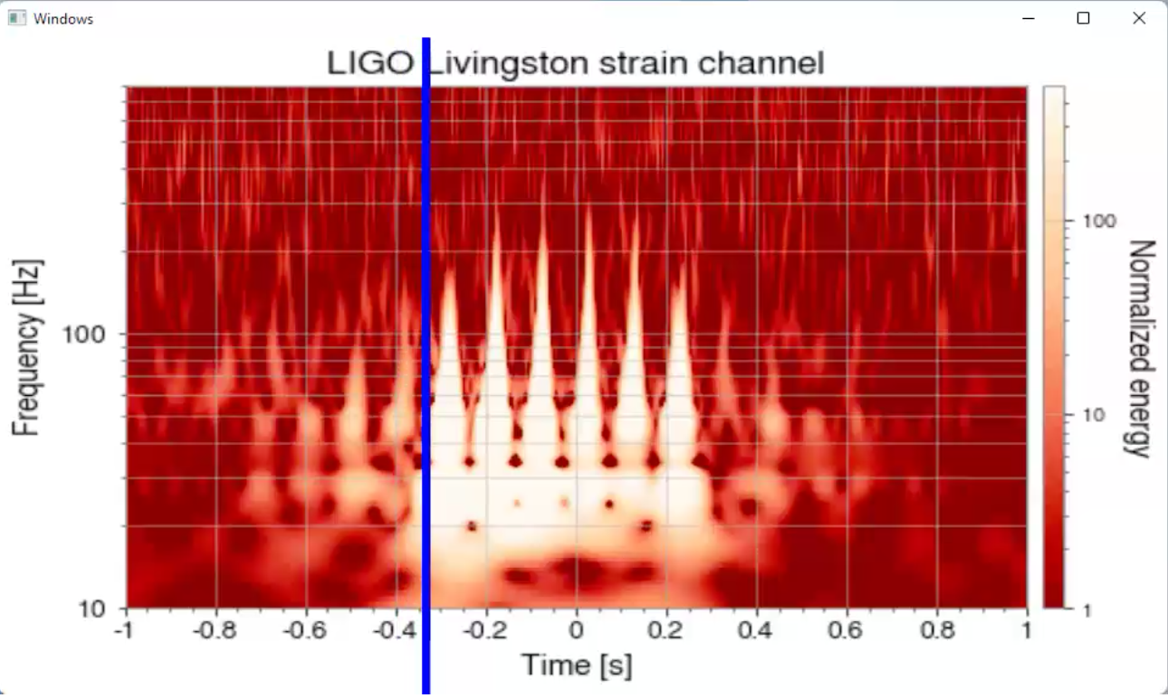

*Figure 1 - The image-sonification script at work on an image of a glitch. The blue vertical line shows the position on the image along the x-axis for which the sound is being reproduced[1].*

## ​2.1 Pre-requisites

To be able to run the image sonification script you must:

* Follow the pre-requisites and run instruction of sonoUno software available on GitHub README (<https://github.com/sonoUnoTeam/sonoUno>) or sonoUno installation manual.
* Install opencv library for python[2], with pip and the basic installation:
  + pip install opencv-python

## 2.1 Run sonification script

To run the image sonification script, go to the sonoUno folder where the script is located in bash and type:

* python3 img_sonif.py -d "path_to_the_image_to_sonify"

# ​3​ New Particle Search at CERN data sonification

Sonification of the New Particle Search at CERN demonstrator data required the design of particular sonification parameters. The HYPATIA[3] event display is used to study events and to identify particle tracks and clusters (Figure 23). The WP7 team began from this starting point, to try to understand each particle representation and to try to represent it with sound.

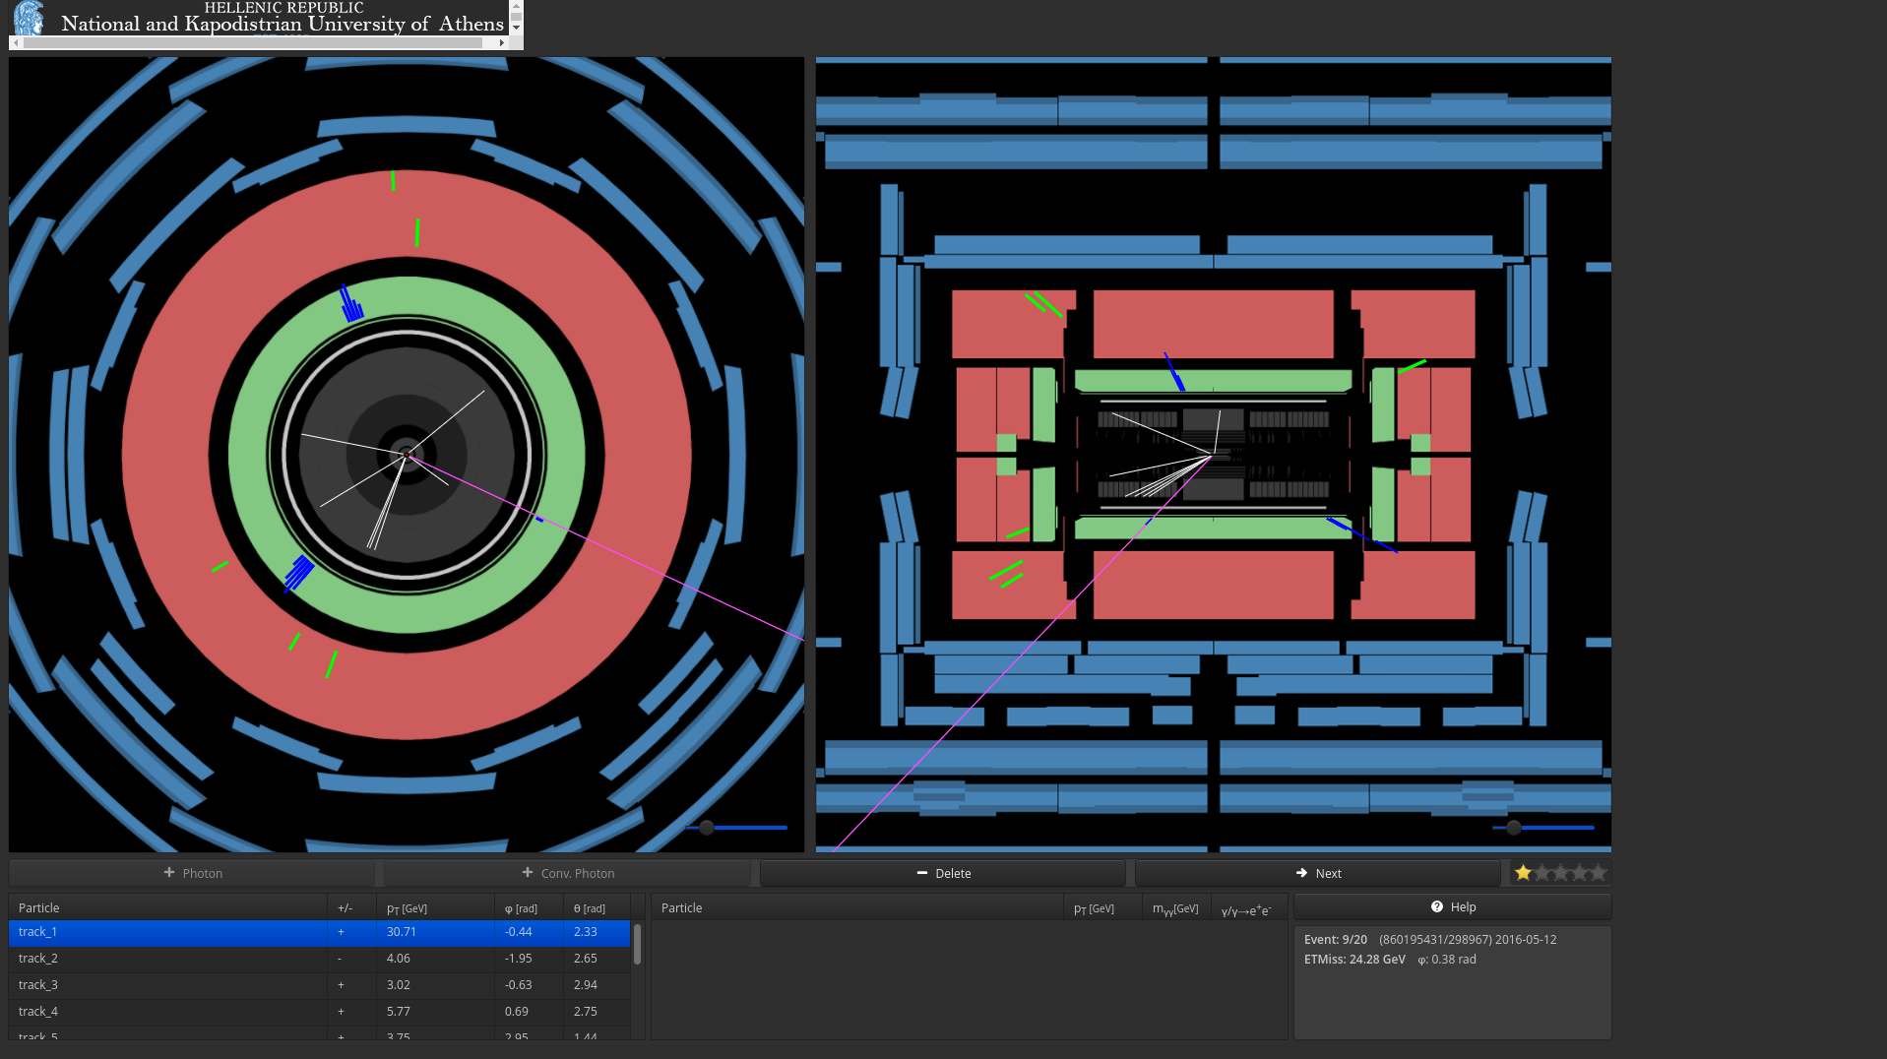

*Figure 23 - The HYPATIA event display, showing event 860195431. On the left, a transversal view, and on the right, a longitudinal view, of the full detector; the particles in the event can be seen in each view* [*(from zooniverse)*](https://www.zooniverse.org/projects/reinforce/new-particle-search-at-cern)

The following particles can be found in the detector and displayed through the HYPATIA program:

* an electron - represented by a track in the inner detector (the central grey area) that points to a cluster in the calorimeter (green area);
* a converted photon - represented by two very close tracks in the inner detector, that points to a cluster in the calorimeter;
* a muon - represented by a long track that goes through all of the detector layers and which could, although this is not necessarily the case, be a point to a cluster;
* a photon - represented by a cluster in the calorimeter, but with no track in the inner detector;
* or unknown - which is considered to be any other representation that is not covered by any of those above.

The WP7 team took each particle display into consideration. First of all, the common characteristics between the different particle-type representations were extracted. These characteristics were:

* the presence or absence of the track in the inner detector;
* the presence or absence of the cluster in the calorimeter;
* and, specifically, considering whether the muon presents a long track.

With these in mind, the next question related to how to produce a sound that represented each situation in sufficiently a general way as to be able to use it with each particle, but to still be able to discriminate between each particle. After several meetings between the WP5 and WP7 teams, the final sonification proposal was to sonify each particle trajectory of an event, using the following sound configuration:

1. A tick mark is represented by a beep sound, which indicates the centre of the detector and the beginning of the particle trip (this sound is present in each particle sonification).
2. To represent the different tracks or the absence of track in the inner detector:
   1. A continuous sound with a specific frequency (piano note ‘D6’, value 1174.66Hz) to represent each single track present in the inner detector (duration of a simple track in the inner detector: 2s); in the case of a muon, the continuous sound is presented with a longer duration time, representing a longer track that exceeds the inner detector (duration of a muon total sound: 4s).
   2. In the case of two tracks, two continuous sounds at two different frequencies are sonified (frequency 1 with piano note ‘D6’, value 1174,66Hz; frequency 2 with piano note ‘C6’, value 1046.50Hz) to represent the two closer tracks in the inner detector (duration of a simple track in the inner detector: 2s).
   3. In the case of the absence of a track, a silence of 2s is sonified.
3. A second tick mark to represent the end of the inner detector and the beginning of the calorimeter (a short ‘F7’ piano note, value 2793.82Hz; duration 1ms).
   1. In the case of muons, this tick mark is sonified after 2 seconds of the beginning of the continuous sound, indicating that the muon passes from the inner detector to the calorimeter.
4. When a cluster exists in the calorimeter, a specific compilation of short sounds is reproduced to represent it, and its volume is related to the energy of the cluster (less energy-lower volume; more energy-higher volume).
   1. In the case of muons, the cluster is sonified during the track sound in the corresponding time (just after the tick mark which indicates the transition to the calorimeter).

The generated script opens a file with some events and the tracks and clusters associated with each event. It separates each event and then identifies the tracks and clusters within them, in order to plot and sonify the data. With the tracks and clusters identified, the script continues with the sonification and plot process, which can be displayed particle by particle[4] (Figure 24) or the script can be run in *bash*, saving the plots and sound files per event.

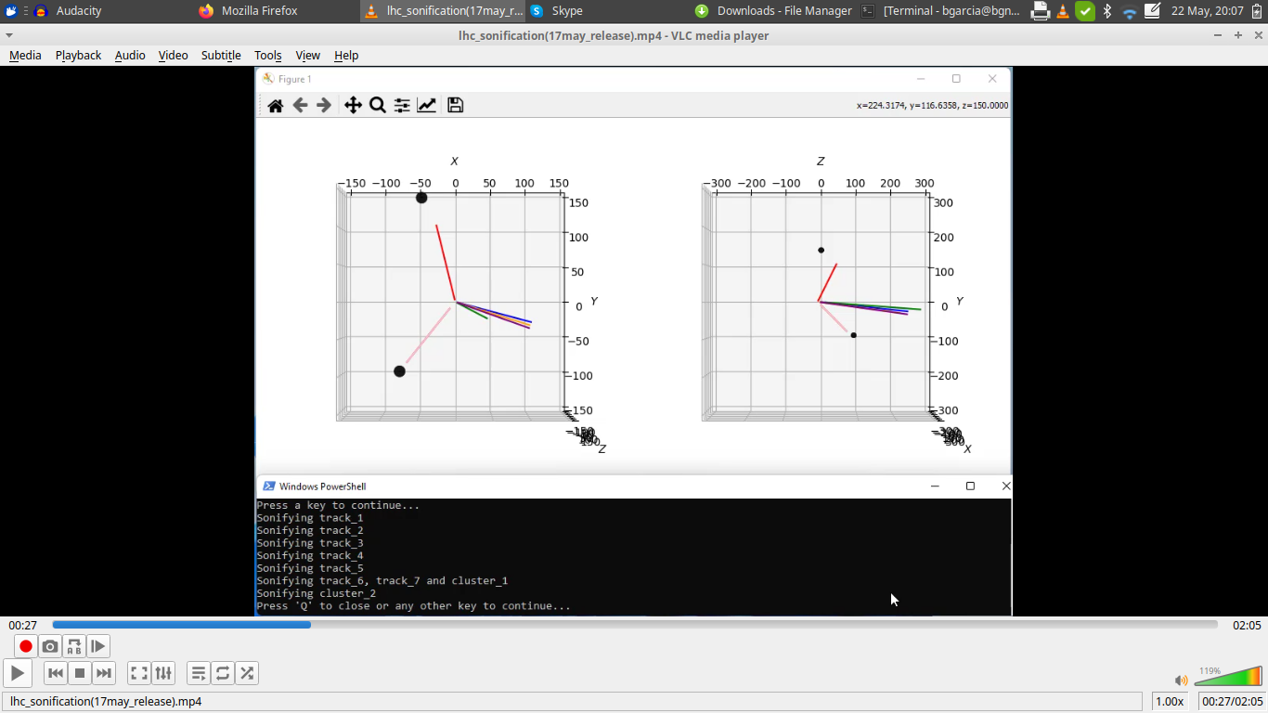

*Figure 24 - The plot generated with the developed script for Event 326146241. On the left, a transversal view, and on the right, a longitudinal view, of the full detector. The clusters are represented by black circles. The sonification action-log is displayed in the area at the bottom.*

Figure 24, below, provides a comparison of how an event displayed in HYPATIA appears when sonified in *sonoUno*.

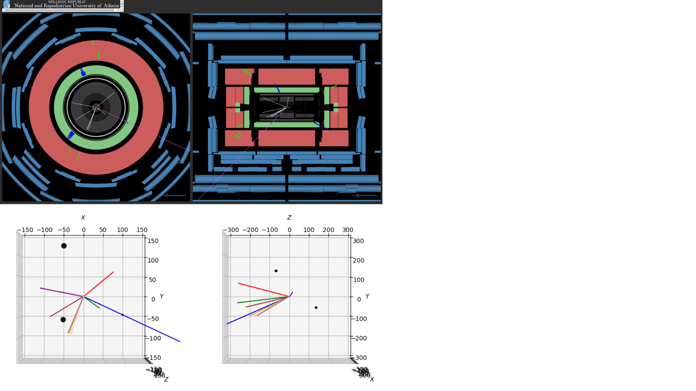

*Figure 25 - A comparison of the event displayed in Figure 23 generated in HYPATIA, with its representation in sonoUno.*

# ​4​ Cosmic Muon data sonification

The muon datasets used in the Cosmic Muon demonstrator project (WP6) are similar in structure to the data used in the New Particle Search at CERN demonstrator. In the case of muon sonification, the objective is to be able to identify if there are any deposits of energy in the three layers of the detector (Figure 26) and to understand if these deposits of energy are aligned. If these to requirements are met, a muon trajectory is present.

The sonification proposal here consists in sonifying the possible track of the muon by matching the deposits of energy.

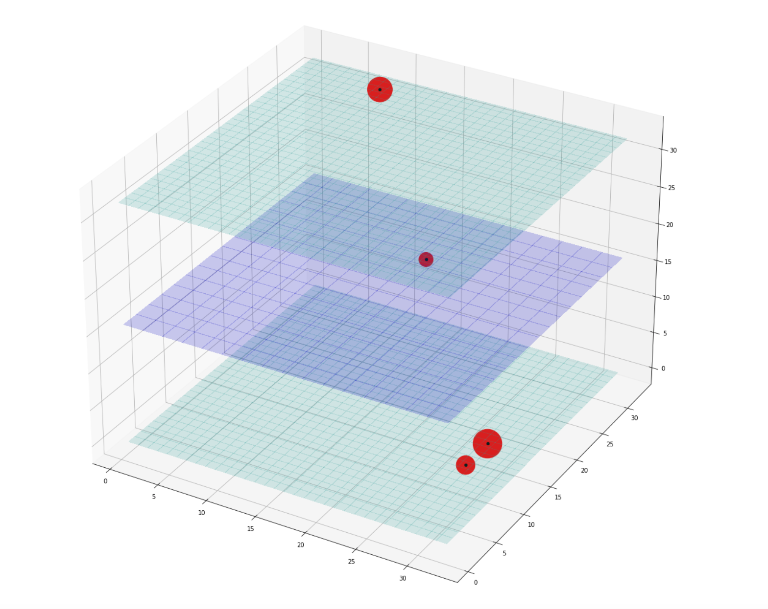

*Figure 26. An example of a graphical representation of the Cosmic Muon Image data, showing the three layers of the detector* [*(from zooniverse*](https://www.zooniverse.org/projects/reinforce/cosmic-muon-images)*)*

## ​

1. Visit the *sonoUno* gallery to see the video: <https://www.sonouno.org.ar/glitch-1126409678-84375/>.
2. <https://pypi.org/project/opencv-python/>
3. <https://hypatia-app.iasa.gr/Hypatia/>
4. <https://drive.google.com/file/d/1UrSdt6wqCehqcoeHILivnm8feHOt1vh7/view?usp=sharing>